**Solution Setup and Design**

Pre-Requisite Software’s required to be installed.

* Cosmos Db Emulator
* Visual Studio 2022 with .Net 6 installed

Solution Folder structure

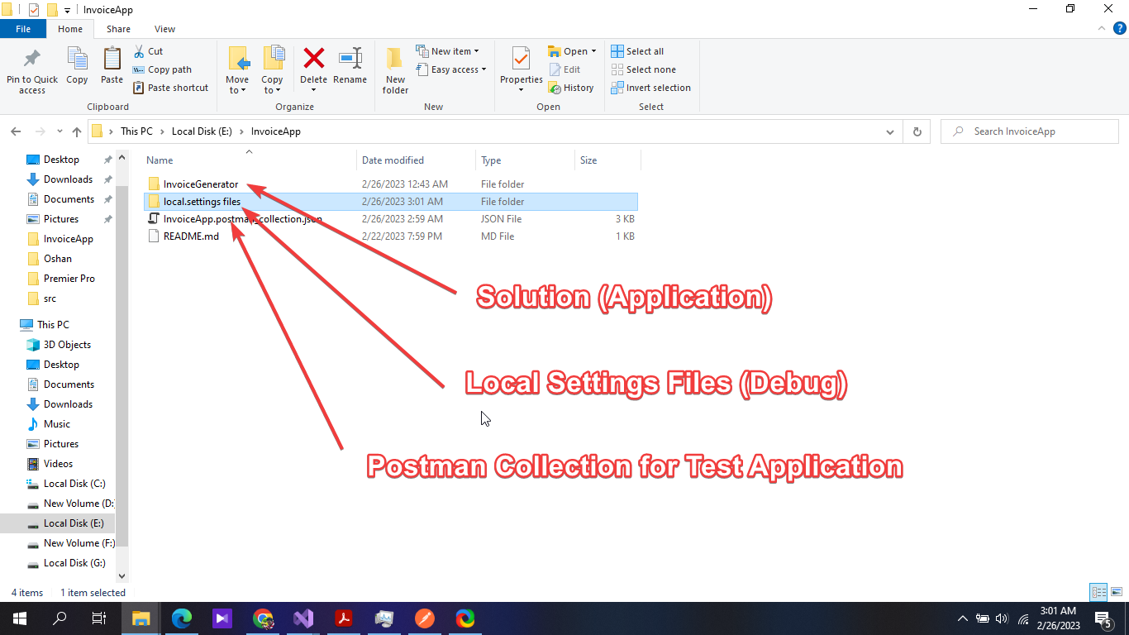

Notes.

* Application is developed using Domain driven design by using Clean Architecture
* Used CQRS pattern with mediator
* Used NUnit For Unit Testing
* Azure function as presentation Logic
* Added cosmos DB as the data persist mechanism.

Clean Architecture

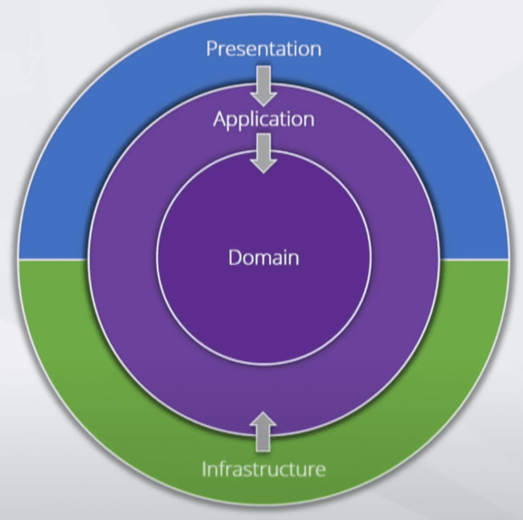

Project Layered Structure

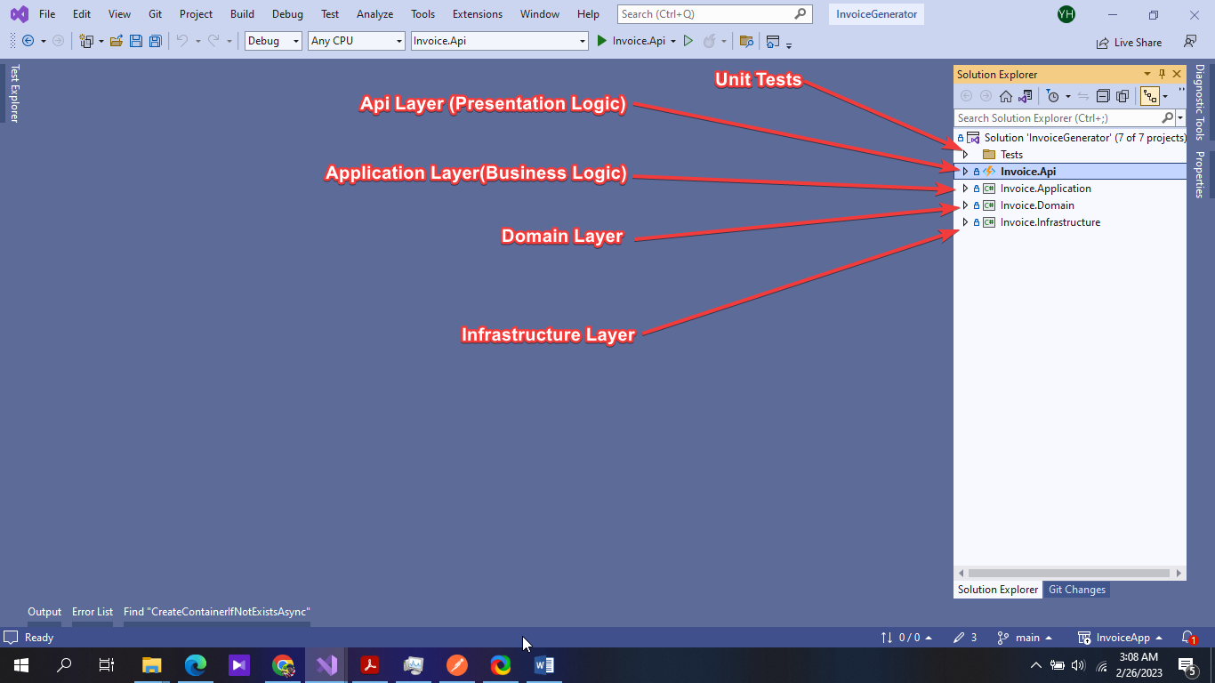

Special Notes

* Project is design in a way to automatically create database and the container if there is no database or container already created.
* If required data seeding in CREATE function prior, have to uncomment the below lines mentioned.

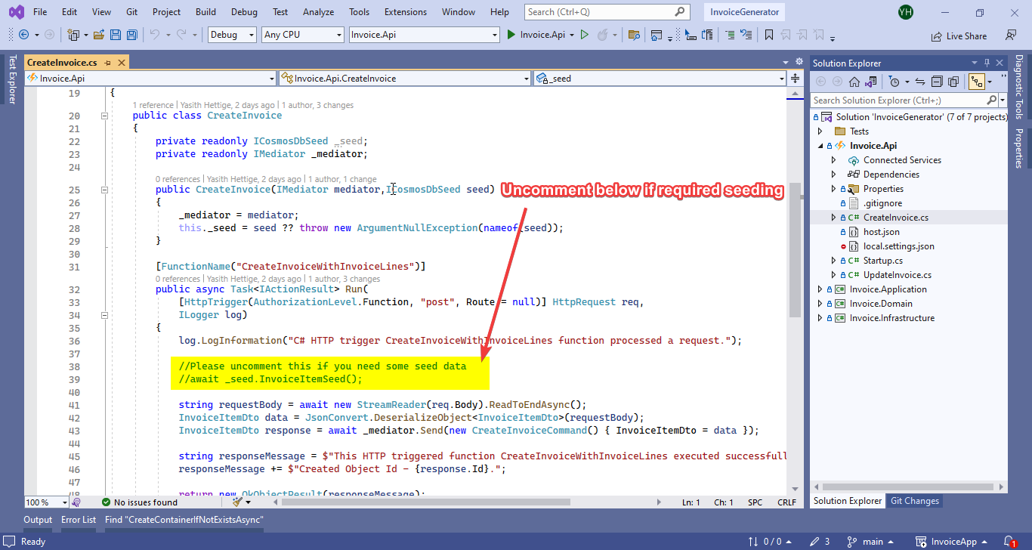

* To Run the Apis Please use the provided Postman Test Collection by importing it to the Postman

